**Tugas IT T-17 Line Detector**

Surya Xips 1/ 21

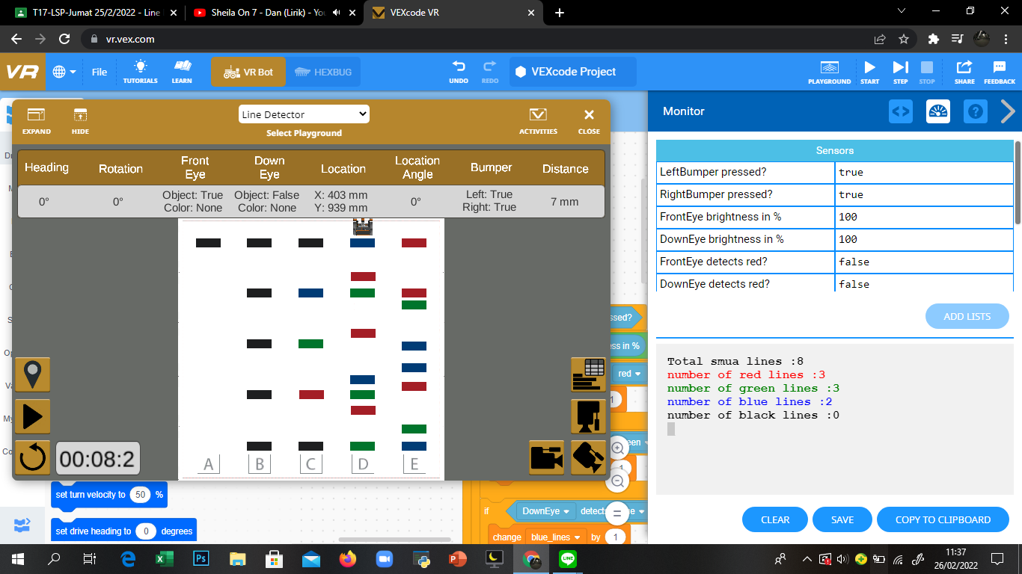

1. Colors counting one Block

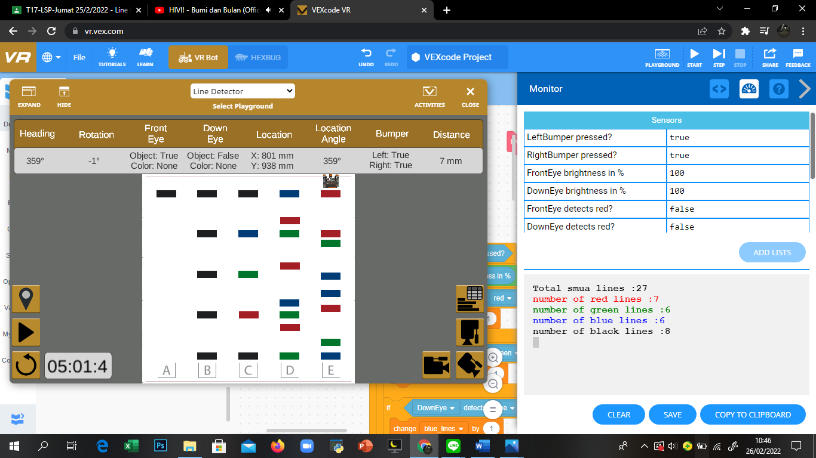

1. Colors counting All Block